Energize Colleges

Campus Application Form

CONTACT: connect@energizecolleges.org
www.energizecolleges.org
Steve Miller
415.507.2186

APPLICATION SUBMISSIONS: Accepted on a rolling basis

INSTRUCTIONS: Please complete all sections of the following application and email your completed campus application in Word or PDF format to connect@energizecolleges.org.

Program Description:
Energize Colleges, funded by California utility rate payers and administered by the Pacific Gas and Electric Company, Southern California Gas Company, Southern California Edison Company, and San Diego Gas and Electric Company under the auspices of the California Public Utilities Commission, seeks to foster the next generation of energy professionals. Strategic Energy Innovations (SEI) serves as the statewide program implementer and is currently accepting applications from campuses to participate, beginning in the 2016-2017 school year and continuing through fall 2018. 12 campuses will participate and receive support from SEI on establishing energy internships and pursuing deeper energy education. For detailed information about Energize Colleges program elements and campus partner benefits and expectations, please review the Energize Colleges website and campus participation agreement found at www.energizecolleges.org.

The goals of this statewide Investor Owned Utility Workforce Education & Training program are to:

- Impart knowledge and skills on energy efficiency (EE), distributed generation (DG), and demand response (DR), with an emphasis on EE.
- Build a qualified workforce that is fully trained and engaged to provide the personnel necessary to achieve long-term energy savings, and
- Identify and build awareness of career options for students in energy-related fields.

Through Energize Colleges, SEI will partner with and support 12 California community colleges, colleges, and universities to participate in this multi-year program.

Energy Internship Program (Work-Based Learning)
Objective: Provide students with training and work experience in EE, DR, and DG to support their career development.

Through this program, the 12 participating campuses will receive consulting, resources, and support to establish or expand a student internship program focused on campus and community energy projects.

The goal of the Energy Internship component of the program is to provide substantive work experience to students who are studying and considering energy career pathways, while also significantly reducing energy use through intern-led projects on campus and (where feasible) out in the community.

Part of each student intern scope will be to make a meaningful connection with high school students in the area, focused on energy education, college/ university programs, and career options.

Energy Education Program (Energy Curriculum & Instruction)
Objective: Integrate energy efficiency (EE), distributed generation (DG), and demand response (DR) concepts in core curricula for accredited degrees, certificates, and/or courses in energy-related fields.

The 12 participating campuses seeking to deepen and expand project-based learning and energy career preparation will receive curriculum and instructional support, teacher training, and implementation assistance.
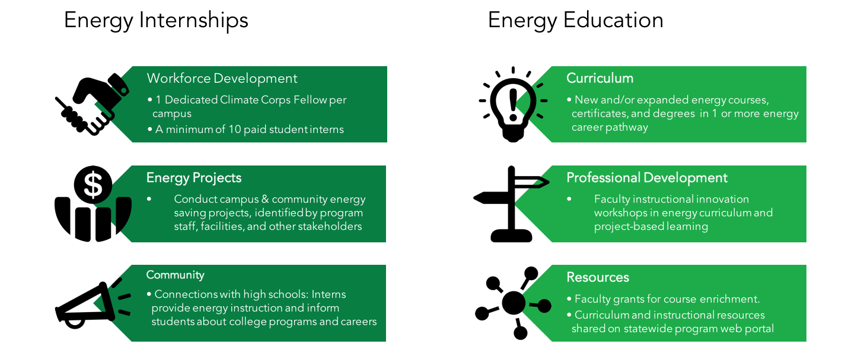

Program Eligibility

Below are the campus eligibility requirements:

- California public or private college, community college, or university.
- Dedication to implementing both components of Energize Colleges: Energy Internships and Energy Education.
- Financial commitment to sustaining the program. On-campus staffing and internship stipends are fully funded in the first year (2016-17) and 50% funded in the second year (2017-18). Please see MOU for more details.
- Commitment from necessary representatives on campus including, but not limited to:
  - College/University President
- CTE Dean
- Facility/Energy Manager
- Sustainability Officer (if applicable)
- Energy-Related Academic Department Head(s)
- Faculty Partners
- Financial Aid Office/Work-Study Manager
- Commitment to sharing the curriculum that is created through the program with Energize Colleges and campuses throughout California.
- Provide an on-campus home for an SEI placed campus Fellow* or provide an alternative full-time employee to serve as Energize Colleges program coordinator across the energy internships and energy education components.

About the Application Process:

If your institution meets the eligibility requirements, please complete the application questions below. These questions are based on requirements and expectations detailed in the campus participation agreement.

A complete application includes the following questions, agreement from the necessary representatives from your institution, indicated in Section B below, and any attachments that you wish to include that will augment your application. Campus Fellow hosting agreements* will be signed when campuses are selected. You will receive a confirmation e-mail after your submission and be contacted by the Energize Colleges team with any questions and final notification or selection.

More details on the application process can be found on the website at www.EnergizeColleges.org.

* See www.energizecolleges.org for details on the Campus Fellow role

A. Introduction Questions
These questions are designed to give SEI a better understanding of your institution and how to best contact representatives of your organization.

Your Name:

Title:

Email:

Phone Number:

Institution Name:

Institution Address:

Campus Office Location:

Which of the following describes your institution?
Community College
California State University
University of California
Private College
Private University

What is the approximate undergraduate enrollment of your institution?

B. Campus Commitment
Broad administrative, staff, and faculty commitment are important to the success of the Energize Colleges program. Through support from administration, key departments, faculty, facilities staff, and student workforce partners, the Energize Colleges program will create student leaders in the new energy economy that are ready to enter the workforce. Please refer to the campus participation agreement for more information on campus expectations for participation in the Energize Colleges program.

Institutional Stakeholders
Providing the name and contact information for your institution’s supporting stakeholders below indicates that they are informed and supportive of this application. Energize Colleges will ask for definitive institutional support from each of these stakeholders at the signing of the campus participation agreement.

Are the following representatives at your institution committed to this program? (Please answer yes, no, or unknown for each stakeholder, and provide key relevant contact information.)
- College President:
Name:
Title:
Contact Info:

- CTE Dean:
Name:
Title:
Contact Info:

- Facility/Energy Manager(s):
Name:
Title:
Contact Info:

- Sustainability Officer:
Name:
Title:
Contact Info:

- Energy-Related Academic Department Head(s):
Name:
Title:
Contact Info:

- Faculty Partners:
Name:
Title:
Contact Info:

- Financial Aid Office/Work-Study Manager/Counselors:
Name:
Title:
Contact Info:

- Other:

C. Energy Internships and Education
Energize Colleges is an energy education and workforce development program that includes both internship and education support. While applicants will be considered regardless of the current status of energy career programs on campus, it is important that your institution is committed to partnering with Energize Colleges in enhancing both energy education and internships available to your students. Both aspects of this program are critical to creating successful energy career pathways that become a sustainable asset at your institution. If additional information on existing academic programs at your campus exists, please attach to this application.

- Is your institution committed to partnering with Energize Colleges to develop your energy career pathways both through student energy education and internships? If yes, please describe your goals for a partnership with Energize Colleges.

- Energize Colleges has a particular focus on the following growing career pathways. Please fill out the following table to indicate the career pathways in which your institution has existing programs, would like support to improve existing programs, or would like to create new pathways, including new courses, certificates, and/or degrees.

Key:
- We have an existing course, certificate, or degree in this career pathway and do not want support to improve this pathway,
- We have an existing course, certificate, or degree in this career pathway and would like support to improve this pathway,
- We do not have this pathway, but would like your support to develop new courses, certificates, and/or degrees in this career pathway

Energy Career Pathways | 1 | 2 | 3
- Energy Engineering: energy efficiency, energy storage, the smart grid, and the energy-water nexus
- Environmental Controls Technology: HVAC, Building Commissioning, Operations, and Building Controls

- Solar Design, Sales, and Estimation

- Installation & Maintenance: EE retrofitting, HVAC, lighting, solar & retro-commissioning

- Energy Auditing

- Energy Storage

- Energy & Environmental Management: utility bill analysis and monitoring, policy, utility program management, and government

- Building Construction & Architecture

- Please describe the existing Energy Education and Workforce Development courses, certificates, degrees, internships, etc. your institution offers, if any. Please describe the new and/or improved initiatives your institution like to pursue with the support of Energize Colleges. Be detailed in your responses, addressing both academic and work-based learning goals.

- Energize Colleges is looking to establish or expand on existing academic courses and programs around EE, DR, and DG at participating colleges. We will support participating faculty in curriculum development around these energy pathways. We are committed to sharing these curriculum materials openly with other colleges and universities around the state. Do you have the commitment of your institution and faculty to share curriculum developed through this program with other colleges in California? Please describe.

- Are there currently student internship programs at your institution where students are working on projects on or off-campus? Please describe. If there are no current campus internship programs, has there been discussion or commitments to establishing such pathways for student applied learning? If not, is it a goal, and is there broad buy-in for creating an internship program at your institution? Please explain.

- Are there established pathways for students to earn academic credit for student internships on your campus? If yes, please describe.

D. Partnerships
Partnerships in the community, in both related industries and with surrounding high schools, will be created during the Energize Colleges program. However, existing relationships that the program can leverage will aid the initial launch of the program. For example, each campus will have at least one active high school partner at which interns will lead energy education and conservation programs with students, informing them about energy career pathways and educational pathways at your college.

- Does your institution have community partners that might be interested in serving as an energy internship project host? If yes, please describe.

- Does your institution have high school partners that might be interested in receiving energy education support from your college interns? If yes, please describe.

- Does your institution have a campus entity, such as in the facilities department, that could be an on-campus host for the Campus Fellow and interns undertaking energy reduction projects on campus? If yes, please describe.

E. Program Sustainability
The Energize Colleges program will be active from Fall 2016 through at least the Fall of 2018. During the first academic year of the program (2016-17), the program will be fully funded by the Investor Owned Utilities. During the second academic year (2017-18), campuses are expected to assume ownership of 50% of the costs associated with paying student interns and providing a campus-based Fellow to coordinate the program. Alternatively, campuses can elect to provide a different full-time program manager at their expense. For the final program term (Fall 2018), participating campuses are expected to transition to full financial ownership of these program elements. Throughout, campuses will continue to benefit from and access no-cost support from the Energize Colleges team, and the online campus portal where course curriculum and resources will be available beyond the term of the program. Support will be provided in pursuing additional resources through grants and other funding opportunities. The campus participation agreement provides more details on program sustainability and funding.

- What channels of funding does your school have to support paid Energize Colleges internships on your campus after the first year of the program? (e.g. Federal Work Study (FWS), Job Location and Development, Student Assistant, Cal Work Study, EOPS, reinvesting utility savings, etc.) Please describe.

- What is the Expected Family Contribution (EFC) threshold for students to qualify for FWS aid at your school?

- Does your institution have any restrictions regarding students working off-campus through work study programs or internships?

- As part of this program, SEI will hire and place a dedicated Fellow on campus to help coordinate all aspects of the Energize Colleges program. (Unless the campus elects to use their own full-time staff member to manage the program instead.) This campus-based Fellow is part of SEI’s Climate Corps (www.climatecorps-bayarea.org) fellowship program and will regularly (monthly) travel to meet with the broader cohort of Fellows for trainings and peer sharing. The Fellow is fully funded by SEI in Year 1 of the program, and campuses must provide 50% funding for a Fellow in Year 2. By Year 3, the campus can choose to host a Fellow at 100% of the cost, or employ an alternate full-time internal employee to manage the program. The costs for hosting a 10-month, dedicated Fellow is estimated at $17,000 (50%) in Year 2, and $34,000 (full costs) in Year 3. How would your institution seek to provide funding for a Campus-based Fellow to help coordinate the program, beginning with partial (50%) support in year 2? Are there existing funding channels at your institution for managing the program with permanent staff or continuing to support a Climate Corps Fellow?

- The estimate for a single Energize Colleges internship position is roughly $1,500 per term, this assumes a maximum of 100 hours per student intern. Is your institution able to commit to providing 50% funding for a minimum of 5 student internships in Year 2 ($3,750) and to fully owning financial support internship stipends by Year 3 ($7,500)? Please describe.

- To ensure the success of the Fellow coordinating the internships and education components, participating campuses must provide for an on-campus supervisor for the Climate Corps Fellow (or alternative program coordinator) in either the CTE department or facilities, with a strong connection to both, and provide for a physical ‘home’ for the Fellow and the sustainability internship program on campus. Please describe your plan to address this requirement.

- Will your institution be able to provide program staff with regular, timely access to campus energy and water data to calculate cost, energy, water, and emissions savings from on-campus projects? Please describe.

Energize Colleges reserves the right to contact the representatives who are included in this application.

As the point of contact for my campus, by submitting this application to Energize Colleges, I agree that I am a representative of my campus and that all information provided here is accurate.

___________________________________ _________________________________
Signature Name

_______________________
Date

